Dorm and Meal Calculator.

package ch12;

import java.awt.*;

import java.awt.event.*;

import javax.swing.*;

/*

Programmer: Peter G Rutherford

Assignment Chapter: Chapter 12

Purpose: My purpose is to learn Java and get a good grade.

Date modified: 02/7/2021

IDE/Toool used: NetBeans IDE 8.2

*/

public class DormMealCalc extends JFrame

{

private JPanel dormPanel;

private JPanel mealPanel;

private JPanel selectedPlanPanel;

private JComboBox dormitories;

private JComboBox mealPlans;

private JLabel label;

private JTextField selectedPlan;

int total;

private String[] dorm = { "Allen Hall: $1,800 per semester", "Pike Hall: $2,200 per semester",

"Farthing Hall: $2,800 per semester", "University Suites: $3,000 per semester",};

private String[] meal = {"7 meals per week: $600 per semester",

"14 meals per week: $1,100 per semester",

"Unlimited meals: $1,800 per semester",};

public DormMealCalc()

{

super("DormMealCalc");

setDefaultCloseOperation(JFrame.EXIT_ON_CLOSE);

setLayout(new BorderLayout());

buildDormMealPanel();

buildSelectedDormPanel();

add(dormPanel, BorderLayout.CENTER);

add(selectedPlanPanel, BorderLayout.SOUTH);

pack();

setVisible(true);

}

private void buildDormMealPanel()

{

dormPanel = new JPanel();

dormitories = new JComboBox(dorm);

mealPlans = new JComboBox(meal);

dormitories.addActionListener(new ComboBoxListener());

mealPlans.addActionListener(new ComboBoxListener());

dormPanel.add(dormitories);

dormPanel.add(mealPlans);

}

private void buildSelectedDormPanel()

{

selectedPlanPanel = new JPanel();

label = new JLabel("Your total: ");

selectedPlan = new JTextField(10);

selectedPlan.setEditable(false);

selectedPlanPanel.add(label);

selectedPlanPanel.add(selectedPlan);

}

private class ComboBoxListener implements ActionListener

{

public void actionPerformed(ActionEvent e)

{

String selection = (String) dormitories.getSelectedItem();

String selection2 = (String) mealPlans.getSelectedItem();

if(selection.equals("Allen Hall: $1,800 per semester")){

total = total + 1800;

} else if(selection.equals("Pike Hall: $2,200 per semester")){

total = total + 2200;

} else if(selection.equals("Farthing Hall: $2,800 per semester")){

total = total + 2800;

} else if(selection.equals("University Suites: $3,000 per semester")){

total = total + 3000;

} else if(selection2.equals("7 meals per week: $600 per semester")){

total = total + 600;

} else if(selection2.equals("14 meals per week: $1,100 per semester")){

total = total + 1100;

} else if(selection2.equals("Unlimited meals: $1,800 per semester")){

total = total + 1800;

}

String str = Integer.toString(total);

selectedPlan.setText(str);

}}

public static void main(String[] args)

{

new DormMealCalc();

}

}

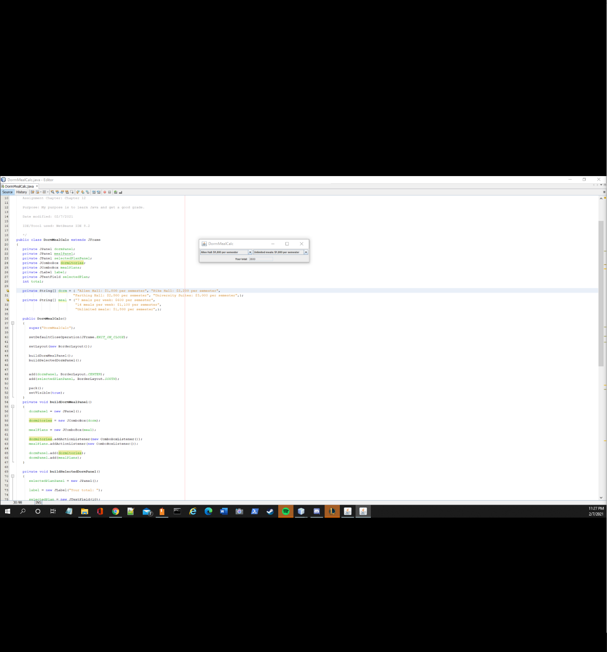

SkateBoardDesigner.java

package ch12;

import java.awt.*;

import java.awt.event.*;

import javax.swing.*;

import javafx.scene.*;

import javafx.scene.control.*;

public class SkateboardDesign extends JFrame

{

private JPanel skateBoardPanel;

private JPanel selectedSkateBoardPanel;

private JComboBox deckBox;

private JComboBox truckBox;

private JComboBox wheelBox;

private JLabel label;

private JLabel label2;

private JLabel label3;

private JTextField totall;

private JTextField tax;

private JTextField subtotal;

private double total;

private String[] deck = { "The Master Thrasher: $60", "The Dictator: $45",

"The Street King: $50"};

private String[] truck = { "7.75-inch axle: $35", "8-inch axle: $40", "8.5-inch axle: $45"};

private String[] wheels = { "51 mm: $20", "55 mm: $22", "58 mm: $24", "61 mm: $28"};

private String[] extra = { "Grip tape: $10", "Bearings: $30", "Riser pads: $2", "Nuts & bolts kit: $3"};

private JList extralist;

public SkateboardDesign()

{

super("Combo Box Demo");

setDefaultCloseOperation(JFrame.EXIT_ON_CLOSE);

setLayout(new BorderLayout());

buildSkateboardPanel();

buildTotalCostPanel();

add(skateBoardPanel, BorderLayout.CENTER);

add(selectedSkateBoardPanel, BorderLayout.SOUTH);

pack();

setVisible(true);

}

private void buildSkateboardPanel()

{

skateBoardPanel = new JPanel();

extralist = new JList(extra);

deckBox = new JComboBox(deck);

truckBox = new JComboBox(truck);

wheelBox = new JComboBox(wheels);

deckBox.addActionListener(new ComboBoxListener());

truckBox.addActionListener(new ComboBoxListener());

wheelBox.addActionListener(new ComboBoxListener());

skateBoardPanel.add(deckBox);

skateBoardPanel.add(truckBox);

skateBoardPanel.add(wheelBox);

skateBoardPanel.add(extralist);

}

private void buildTotalCostPanel()

{

selectedSkateBoardPanel = new JPanel();

label = new JLabel("Total Cost: ");

totall = new JTextField(10);

totall.setEditable(false);

label2 = new JLabel("Tax: ");

tax = new JTextField(10);

tax.setEditable(false);

label3 = new JLabel("SubTotal: ");

subtotal = new JTextField(10);

subtotal.setEditable(false);

selectedSkateBoardPanel.add(label);

selectedSkateBoardPanel.add(totall);

selectedSkateBoardPanel.add(label2);

selectedSkateBoardPanel.add(tax);

selectedSkateBoardPanel.add(label3);

selectedSkateBoardPanel.add(subtotal);

}

private class ComboBoxListener implements ActionListener

{

public void actionPerformed(ActionEvent e)

{

String selection = (String) deckBox.getSelectedItem();

String selection2 = (String) truckBox.getSelectedItem();

String selection3 = (String) wheelBox.getSelectedItem();

String selection4 = (String) extralist.getSelectedValue();

if(selection.toString().equals("The Master Thrasher: $60")){

total = total + 60;

} else if(selection.toString().equals("The Dictator: $45")){

total = total + 45;

} else if(selection.toString().equals("The Street King: $50")){

total = total + 50;

} else if(selection2.toString().equals("7.75-inch axle: $35")){

total = total + 35;

} else if(selection2.toString().equals("8-inch axle: $40")){

total = total + 40;

} else if(selection2.toString().equals("8.5-inch axle: $45")){

total = total + 45;

} else if(selection3.toString().equals("51 mm: $20")){

total = total + 20;

} else if(selection3.toString().equals("55 mm: $22")){

total = total + 22;

} else if(selection3.toString().equals("58 mm: $24")){

total = total + 24;

} else if(selection3.toString().equals("61 mm: $28")){

total = total + 28;

} else if(selection4.equals(extra[0])){

total = total + 10;

} else if(selection4.toString().equals("Bearings: $30")){

total = total + 30;

} else if(selection4.toString().equals("Riser pads: $2")){

total = total + 2;

} else if(selection4.toString().equals("Nuts & bolts kit: $3")){

total = total + 3;

}

String substr = Double.toString(total);

String str = Double.toString(total + total*.07);

String taxstr = Double.toString(total*.07);

totall.setText(str);

tax.setText(taxstr);

subtotal.setText(substr);

}

}

public static void main(String[] args)

{

new SkateboardDesign();

}

}

